**ASSINGMENT-1**

**SUBJECT- JAVA**

**UID-22BCS11558**

**NAME-NIKHIL**

**PROBLEM 1:-Product Class (Easy Level)**

1. **CODE:-**

class Product {

int id;

String name;

double price;

Product(int id, String name, double price) {

this.id = id;

this.name = name;

this.price = price;

}

void displayDetails() {

System.out.println("Product Details:");

System.out.println("ID: " + id);

System.out.println("Name: " + name);

System.out.println("Price: " + price);

}

}

public class ProductDemo {

public static void main(String[] args) {

Product p = new Product(101, "Laptop", 75000);

p.displayDetails();

}

}

1. **SCREENSHOT:-**

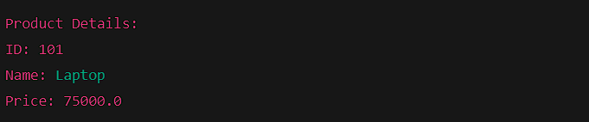

**Problem 2: Library Management System (Medium Level)**

1. **CODE:-**

class Book {

String title;

String author;

double price;

Book(String title, String author, double price) {

this.title = title;

this.author = author;

this.price = price;

}

void displayDetails() {

System.out.println("Title: " + title);

System.out.println("Author: " + author);

System.out.println("Price: " + price);

}

}

class Fiction extends Book {

Fiction(String title, String author, double price) {

super(title, author, price);

}

void display() {

System.out.println("Fiction Book Details:");

displayDetails();

}

}

class NonFiction extends Book {

NonFiction(String title, String author, double price) {

super(title, author, price);

}

void display() {

System.out.println("Non-Fiction Book Details:");

displayDetails();

}

}

public class LibrarySystem {

public static void main(String[] args) {

Fiction book1 = new Fiction("Harry Potter", "J.K. Rowling", 500);

NonFiction book2 = new NonFiction("Sapiens", "Yuval Noah Harari", 700);

book1.display();

System.out.println();

book2.display();

}

}

1. **SCREENSHOT:-**



**Problem 3:- Student Information System (Hard Level)**

1. **CODE:-**

abstract class Person {

String name;

int age;

Person(String name, int age) {

this.name = name;

this.age = age;

}

abstract void displayDetails();

}

class Student extends Person {

int rollNumber;

Student(String name, int age, int rollNumber) {

super(name, age);

this.rollNumber = rollNumber;

}

void displayDetails() {

System.out.println("Student Details:");

System.out.println("Name: " + name);

System.out.println("Age: " + age);

System.out.println("Roll Number: " + rollNumber);

}

}

class Teacher extends Person {

String subject;

Teacher(String name, int age, String subject) {

super(name, age);

this.subject = subject;

}

void displayDetails() {

System.out.println("Teacher Details:");

System.out.println("Name: " + name);

System.out.println("Age: " + age);

System.out.println("Subject: " + subject);

}

}

public class StudentInfoSystem {

public static void main(String[] args) {

Student student = new Student("Alice", 20, 101);

Teacher teacher = new Teacher("Mr. Smith", 40, "Mathematics");

student.displayDetails();

System.out.println();

teacher.displayDetails();

}

}

1. **SCREENSHOT:-**

